**Men’s Conference Registration Form**

**October 18-19, 2019**

**Friday – Oct. 18th – Begins with dinner at 6 p.m.**

**Saturday – Oct. 19th – Ends at 4 p.m.**

**Cost: $100/person**

**Name ____________________________________________________________________________**

**Address __________________________________________________________________________**

**_________________________________________________________________________________**

**Phone ____________________________ Cell Phone ____________________________________**

**Church Name and Town ____________________________________________________________**

**Email Address ____________________________________________________________________**

C:\Documents and Settings\Sandy\Local Settings\Temporary Internet Files\Content.IE5\NQCRSFJ6\MC900129382[1].wmfC:\Documents and Settings\Sandy\Local Settings\Temporary Internet Files\Content.IE5\NQCRSFJ6\MC900129382[1].wmf

_ _ _ _ _ _ _ _ _ _ _ _ _ _ _ _ _ _ _ _ _ _ _ _ _ _ _ _ _ _ _ _ _ _ _ _ _ _ _ _ _ _ _ _ _ __ _ _ _ _ _ _ _ _ __ _ _ _

Schedule of Activities

**FRIDAY – Oct. 18**

**6 pm – Dinner – Parmesan chicken with potatoes, rice, and vegetables**

**7 pm – Evening Session – Dr. Ken Gillming**

**SATURDAY – Oct. 19**

**7:30 to 8:00 am – Breakfast – Country Breakfast**

**8:00 to 8:45 am – Personal Devotion Time**

**8:45 to 9:45 – First Morning Session**

**9:45 to 10:00 am – Break**

**10:00 to 11:00 am – Second Morning Session**

**11:00 to 11:15 – Break**

**11:15 to 12:15 pm – Third Session**

**12:30 to 1:00 pm – Lunch – Sub Bar**

**1:00 to 3:30 pm – Activity Time**

**Trap – Golf Driving Range – Basketball – Hiking Trails – Horseshoes - Foosball – Fellowship and Relaxation**

**3:30 to 4:00 pm – Departing Spiritual Charge**

**Bring your own sheets and blankets (or a sleeping bag), along with towels and toiletry articles. There will be trap shooting. Feel free to

bring your own shotgun and ammo. Remember, safety is paramount. Golf clubs and balls are available for the golf driving range, or

you may bring your own.

VICTORY BAPTIST CHURCH

P. O. Box 160

Vergennes, Vermont 05491

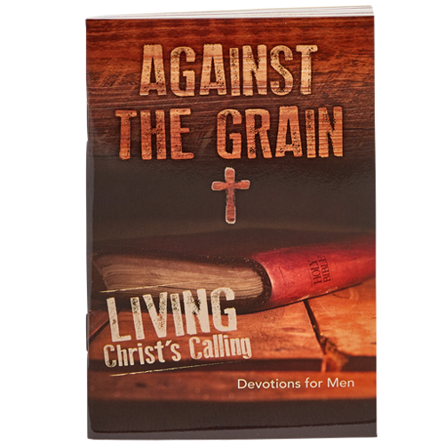

**VERMONT BAPTIST**

**MEN’S CONFERENCE 2019**

Register Online Today!

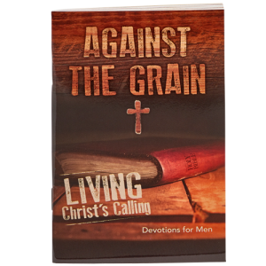

Vermont

Baptist

Men’s Conference

Register Online Now!

7th

Annual

October 18-19, 2019

Held at scenic Singing Hills Christian Retreat in Plainfield, NH

**OUR KEYNOTE SPEAKER IS . . . .**

Bro. Ken Gillming served as Senior Pastor of Cherry Street Baptist Church in Springfield, Missouri, for over three decades. Ken and his brothers are avid outdoors men. Hunting and fishing are part of their heritage. From Ozark turkeys to fishing off the jetties in New England, Bro. Ken loves it all. A number of years ago, he and his wife, Shirley, moved to the Boston area. His wife has retired and Bro. Gillming teaches several classes and is the Vice President of Student Services at Boston Baptist College.

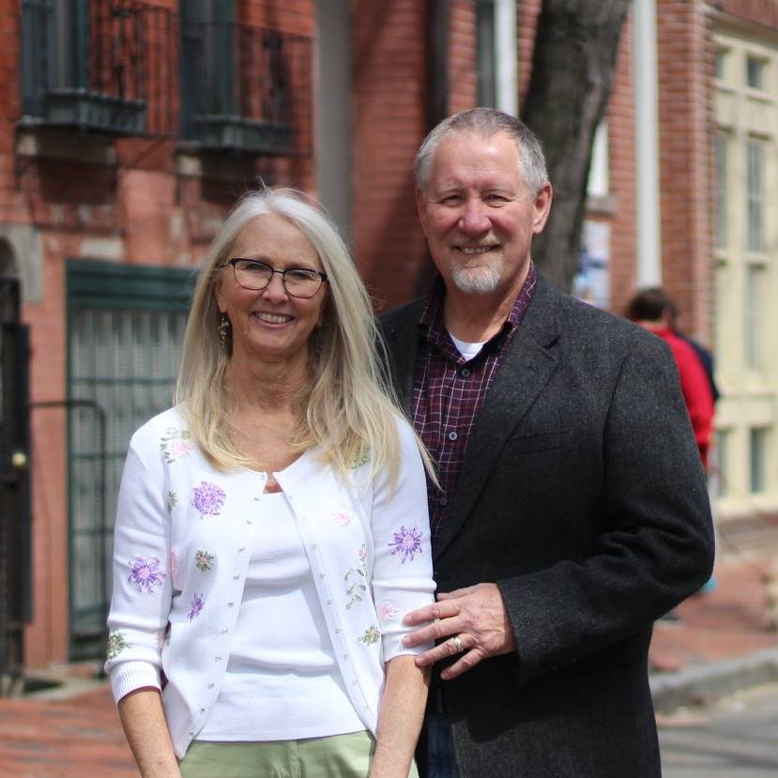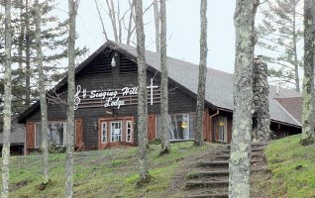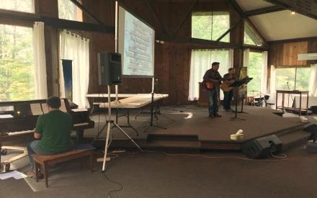

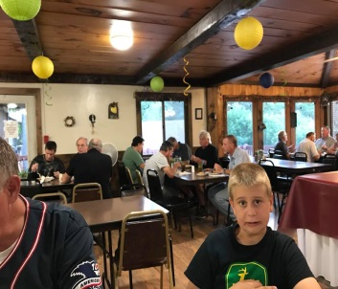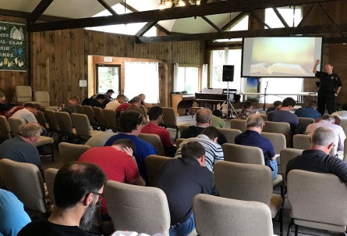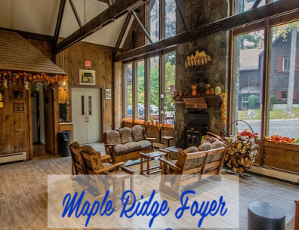

Friday, October 18 @ 6 p.m.   
through  
Saturday, October 19 @ 4 p.m.

SECOND YEAR AT NEW LOCATION: **Singing Hills Christian Retreat**   
71 King Dr.   
Plainfield, NH 03781

Your **$100** fee includes: lodge accommodations, trap shooting, golf driving range, basketball, hiking, great food, fellowship, and preaching.

*Snack Shop with snacks and drinks available for purchase.

Mail your registration or register online at [www.victoryvt.org](http://www.victoryvt.org)   
Victory Baptist Church | P.O. Box 160 | Vergennes, Vermont 05491

**Menu Highlights**

**Friday Night**

Parmesan chicken, potatoes, rice, vegetables

**Saturday Morning**

Country Style Breakfast with Venison Steak

**Lunch**

Sub Bar with Venison Chili